B1005-4P-65W
5 Ports 10/100M POE Switch（CCTV mode optional）

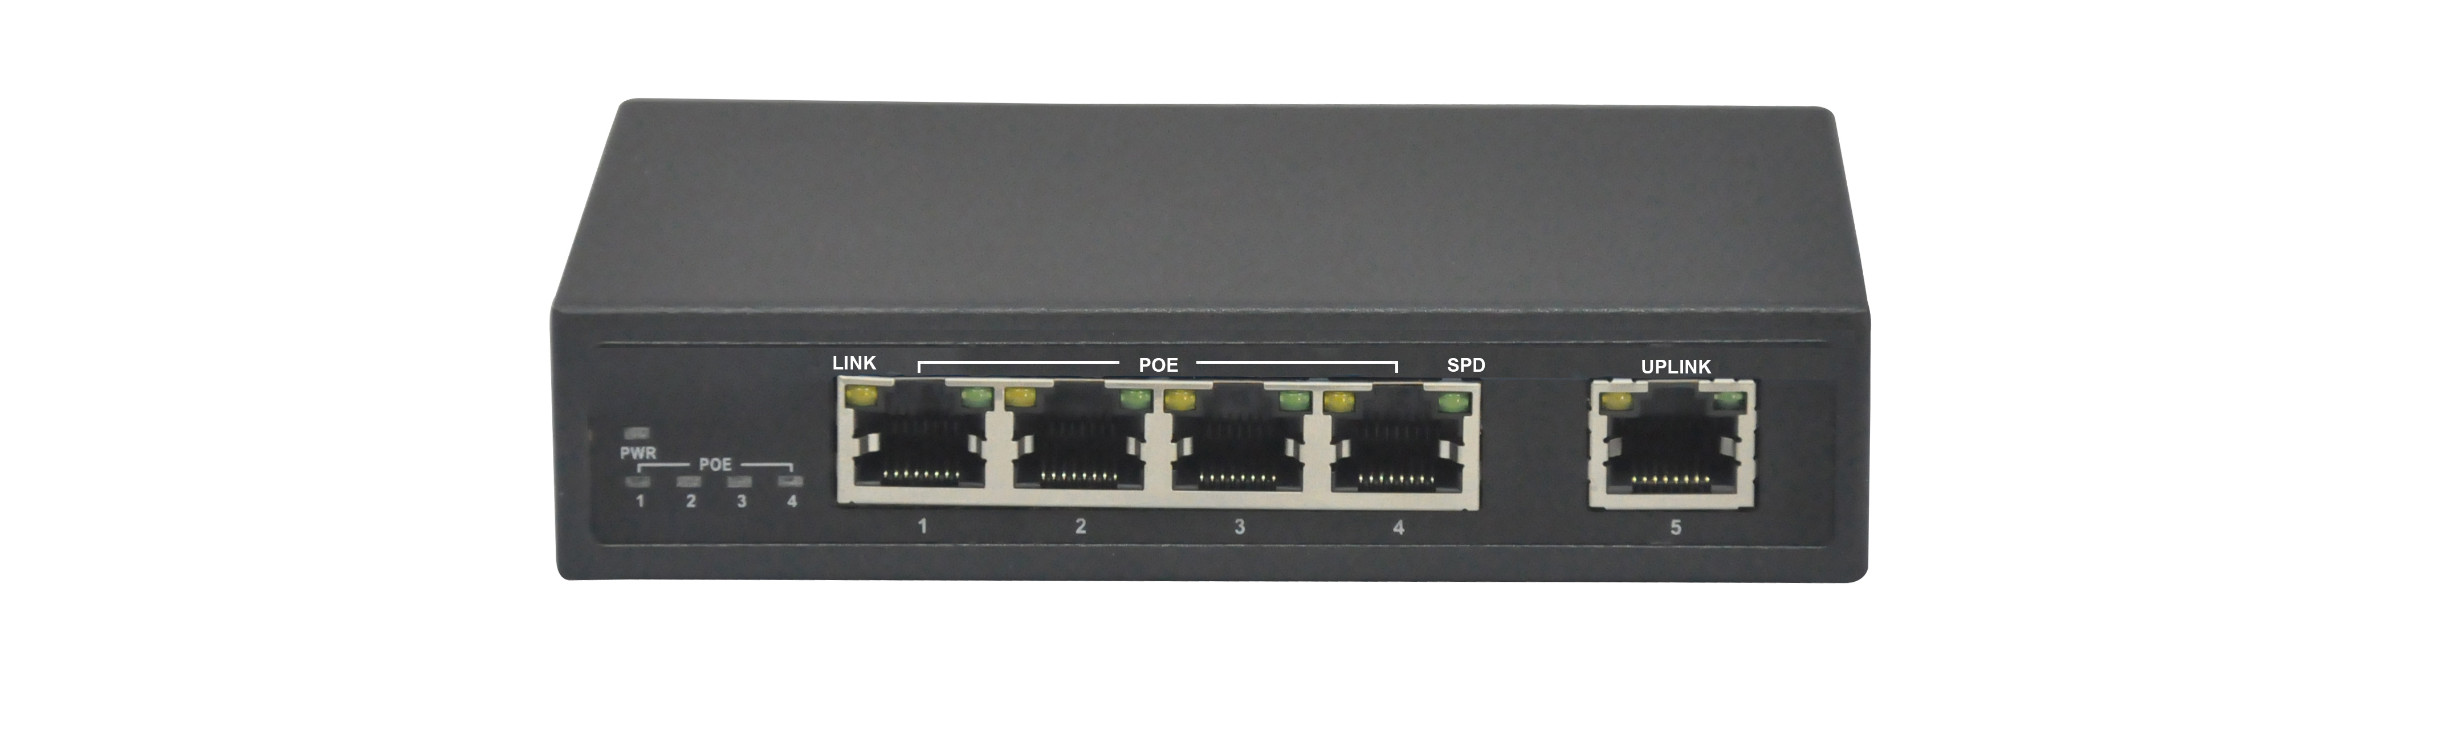

Product Description:
B1005-4P-65W is 5 ports 10/100M POE Switch. It provides 5 10/100Mbps Auto-Negotiation RJ45 ports and 4 ports with POE function (Port 2-5), the POE ports support full POE standard: IEEE802.3af and IEEE802.3at. The product supports one key CCTV mode, open it, the switch can achieve VLAN after configuration, control the Net storm, protect the information security, prevent the viral transmission and Ethernet attack, fully satisfy the Ethernet video security surveillance system and Ethernet project needs. And also it can extend the transport distance to 250M by the 10M data under the CCTV mode.
This model has three optional power supplies for your choice (65W, 96W, 135W, can choose from the order list). Extend Function: Port Lightning protection, Power lightning protection.

Products Features:
• IEEE802.3, IEEE 802.3u, IEEE 802.3ab, IEEE802.3z, IEEE802.3af, IEEE802.3at
• Provides 5 10/100Base-TX ports
• 4 POE Ports (Ports 2-5), Each POE port output 30W max power
• One key CCTV mode; 2～5 downlink ports can only communicate with uplink ports
• One key CCTV mode: The transport distance will support 250M under 10M
• High back-plane bandwidth 1Gbps
• Reliable Power Adapter supply power for both network switch and POE
• Three optional power adapters: 65W, 96W, 135W
• 1K entry MAC address table of the PoE switch with auto-learning and auto-aging
• IEEE802.3x Flow control for Full-duplex Mode and backpressure for Half-duplex Mode
• Surge protection for power port and data ports
• Supports PoE IEEE 802.3af or IEEE802.3at compliant Powered Device (PD)
• Compact metal case for desktop or wall-mounting.
• EMI standards complies with FCC, CE class B

Products Specifications:
Item | Description
Summarize
Fixed port | 5 10/100Mbps RJ45 port
POE Port | 4 PoE ports (Port 2-5)
LED Indicators | PWR, PoE, Link/Act LED.
Input voltage | 100V～240V AC，50/60Hz (for power adapter)  48VDC (for switch)
Network Media | 10BASE-TX: UTP category 5, 5e cable (≤250m)  100BASE-TX: UTP category 5, 5e cable (≤150m)
Forwarding Rate | 10BASE-T: 14880pps/port  100BASE-TX: 148800pps/port
Power Supplies | 65W,96W,135W Optional
Operating temperature | 0℃～40℃.
Storage temperature | -10℃～70℃.
Relative humidity | 20%～85% (non-condensing).
Thermal methods | Fanless
Switching capacity | 1G.
MAC address table | 1K.
Traffic control | IEEE 802.3x full-duplex flow control.
Package Size | 19.1*14.1*6.4cm
Weight | <2Kg
Package | B1005-4P-65W POE switch  User Manual  Warranty Card  Power Adapter  Power Cable
PoE
PoE port | 4 10/100Base-TX ports.
PoE Standard | IEEE802.3af, IEEE802.3at, per port 15.4W,max 30W
Pin assignment | V+ (RJ45 Pin 3, 6), V- (RJ45 Pin 1, 2).
Extend Function | Port Lightning protection, Power lightning protection, solid vlan.

Order Information
B1005-4P-65W | 5 ports network Switch with 4 PoE Ports(Total Power 65W)
B1005-4P-96W | 5 ports network Switch with 4 PoE Ports(Total Power 96W)
B1005-4P-135W | 5 ports network Switch with 4 PoE Ports(Total Power 135W)

