BN1010-8P+2C(G)-150W
8+2G Ports Desktop POE Switch with internal power supplies
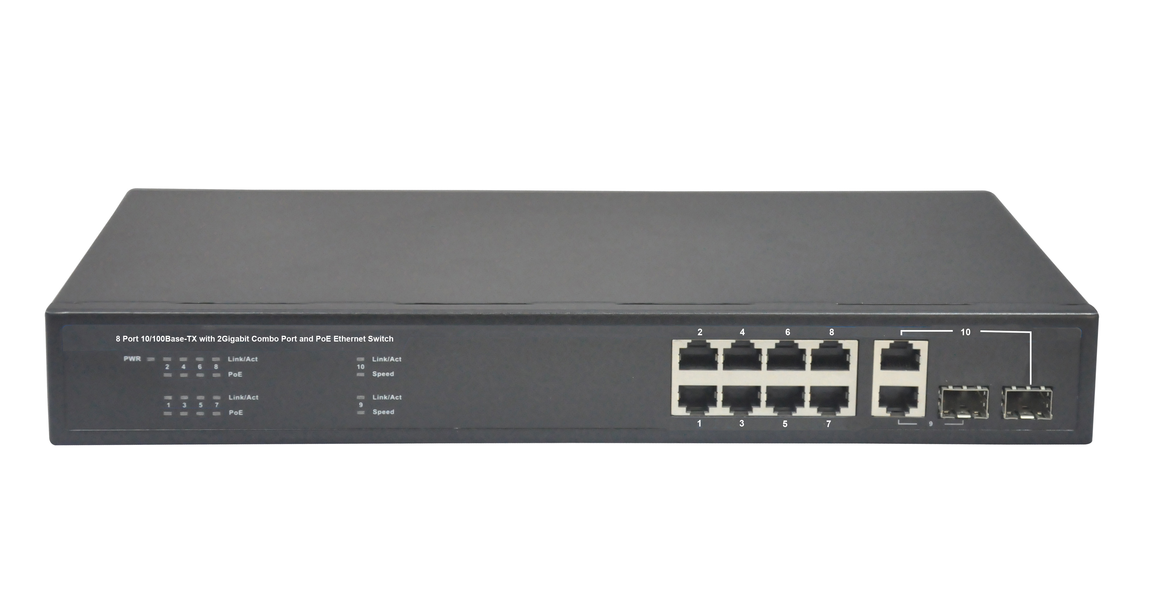
Product Description:
The BN1010-8P+2C(G)-150W is a 8 ports 10/100M and two Gigabit Uplink Combo Ports desktop POE Switch. It is used for residential building in the corridor-level broadband switching equipment, for the edge of the access and LAN to provide high-quality network connections. It provides 8 10/100Mbps Auto-Negotiation RJ45 ports, 2 Gigabit Combo Ports (SFP+RJ45) and 8 POE ports. The POE ports can automatically detect and supply power for the IEEE802.3af and IEEE802.3at compliant Powered Devices (PDs), like Voip Phone, PoE APs, IP Phones, IP cameras, etc.
The BN1010-8P+2C(G)-150W is a 13’’ case-shaped device with 1U high. It is with the internal industrial power supplies, have two optional power supplies—150W, 270W. All POE ports support both IEEE802.3af and IEEE802.3at Standard; each port can output 30W max.

Product Features:
- IEEE802.3, IEEE 802.3u, IEEE 802.3ab, IEEE802.3z, IEEE802.3af, IEEE802.3at
- Provides 8 10/100Base-TX ports, 2 Gigabit Combo Ports (SFP+RJ45)
- Provides 8 PoE ports, Each POE port output 30W max power
- Build in power supplies, optional 150W or 270W
- High back-plane bandwidth 5.6Gbps
- 4K entry MAC address table of the PoE switch with auto-learning and auto-aging
- IEEE802.3x Flow control
- Surge protection for power port and data ports
- 19’’ rack-mounted size metal case for the POE switch
- Pin Feet: V+ (RJ45 Pin 1, 2), V- (RJ45 Pin 3, 6)
- EMI standards complies with FCC, CE class B
- Extend Function: Power lightning protection, solid vlan.

Product Specifications:
Item | Description
Summarize
Fixed port | 8 10/100Base-TX ports. 2 Gigabit Combo Ports( SFP+RJ45)
LED Indicators | PWR, PoE, Link/Act LED.
Input voltage | 100V～240V AC，50/60Hz
Network Media | 10BASE-TX: UTP category 5, 5e cable (≤250m)  100BASE-TX: UTP category 5, 5e cable (≤150m)  Uplink Fiber Port: Single Fiber 20KM, Double Fiber: 20Km
Forwarding Rate | 10BASE-T: 14880pps/port  100BASE-TX: 148800pps/port
Power Supplies | 150W, 270W Optional
Operating temperature | 0℃～40℃.
Storage temperature | -10℃～70℃.
Relative humidity | 20%～85% (non-condensing).
Thermal methods | Built-in Noiseless FAN.
Switching capacity | 5.6G.
MAC address table | 4K.
Traffic control | IEEE 802.3x full-duplex flow control.
Weight | <3 Kg
Package | BN1010-8P+2C(G)-150W POE switch  User Manual  Power Cable  Warranty Card
PoE
PoE port | 8 10/100Base-TX ports.
PoE Standard | IEEE802.3af, IEEE802.3at, per port 15.4W, max 30W
Pin assignment | V+ (RJ45 Pin 1, 2), V- (RJ45 Pin 3, 6).

Order Information
BN1010-8P+2C(G)-150W | 10 ports network Switch with 150 PoE Ports(Total Power 150W)
BN1010-8P+2C(G)-270W | 10 ports network Switch with 270 PoE Ports(Total Power 270W)

