BN1018-16P+2C(G)-270W
16+2G Ports Desktop POE Switch with internal power supplies
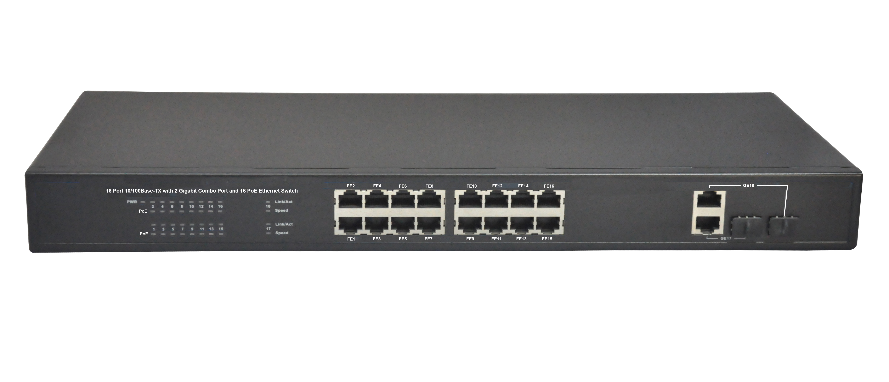
Product Description:
The BN1018-16P+2C(G)-270W is a 16 ports 10/100M and two Gigabit Uplink Combo Ports desktop POE Switch. It is used for residential building in the corridor-level broadband switching equipment, for the edge of the access and LAN to provide high-quality network connections. It provides 16 10/100Mbps Auto-Negotiation RJ45 ports, 2 Gigabit Combo Ports (SFP+RJ45). The POE ports can automatically detect and supply power for the IEEE802.3af and IEEE802.3at compliant Powered Devices (PDs), like Voip Phone, PoE APs, IP Phones, IP cameras, etc.
The BN1018-16P+2C(G)-270W is a 13’’ case-shaped device with 1U high. It is with the internal industrial power supplies, have two optional power supplies—150W, 270W. All POE ports support both IEEE802.3af and IEEE802.3at Standard; each port can output 30W max.

Product Features:
- IEEE802.3, IEEE 802.3u, IEEE 802.3ab, IEEE802.3z, IEEE802.3af, IEEE802.3at
- Provides 8 10/100Base-TX ports, 2 Gigabit Combo Ports (SFP+RJ45)
- Provides 8 PoE ports, Each POE port output 30W max power
- Build in power supplies, optional 150 or 270W
- High back-plane bandwidth 5.6Gbps
- 4K entry MAC address table of the PoE switch with auto-learning and auto-aging
- IEEE802.3x Flow control
- Surge protection for power port and data ports
- 19’’ rack-mounted size metal case for the POE switch
- Pin Feet: V+ (RJ45 Pin 1, 2), V- (RJ45 Pin 3, 6)
- EMI standards complies with FCC, CE class B
- Extend Function: Power lightning protection, solid vlan.

Product Specifications:
Item | Description
Summarize
Fixed port | 16 10/100Base-TX ports. 2 Gigabit Combo Ports( SFP+RJ45)
LED Indicators | PWR, PoE, Link/Act LED.
Input voltage | 100V～240V AC，50/60Hz
Network Media | 10BASE-TX: UTP category 5, 5e cable (≤250m)  100BASE-TX: UTP category 5, 5e cable (≤150m)  Uplink Fiber Port: Single Fiber 20KM, Double Fiber: 20Km
Forwarding Rate | 10BASE-T: 14880pps/port  100BASE-TX: 148800pps/port
Power Supplies | 150W, 270W Optional
Operating temperature | 0℃～40℃.
Storage temperature | -10℃～70℃.
Relative humidity | 20%～85% (non-condensing).
Thermal methods | Built-in Noiseless FAN.
Switching capacity | 5.6G.
MAC address table | 4K.
Traffic control | IEEE 802.3x full-duplex flow control.
Weight | <3 Kg
Package | BN1018-16P+2C(G)-270W POE switch  User Manual  Power Cable  Warranty Card
PoE
PoE port | 16 10/100Base-TX ports.
PoE Standard | IEEE802.3af, IEEE802.3at, per port 15.4W, max 30W
Pin assignment | V+ (RJ45 Pin 1, 2), V- (RJ45 Pin 3, 6).

Order Information
BN1018-16P+2C(G)-150W | 18 ports network Switch with 16 PoE Ports(Total Power 150W)
BN1018-16P+2C(G)-270W | 18 ports network Switch with 16 PoE Ports(Total Power 270W)

