Q1009-8P-96W
9 RJ-45 10/100/1000M Ports POE Switch
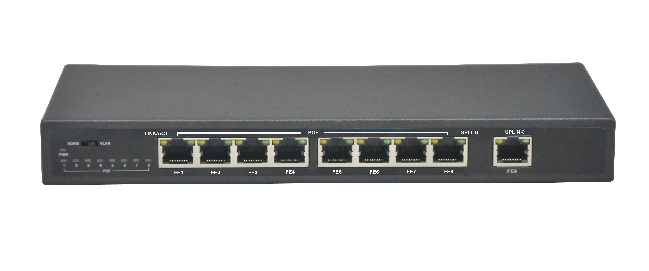
Products Description:
The Q1009-8P-96W is a useful 9 ports Gigabit POE switch with a gigabit SFP uplink port. It provides 9 10/100/1000M RJ45 Ports and 4 or 8 PoE Ports. The POE ports can automatically detect and supply power for the IEEE802.3af and IEEE802.3at compliant Powered Devices (PDs), like Voip Phone, PoE APs, IP Phones, IP cameras, etc.
The Q1009-8P-96W is a small size metal-shell device which is useful for the small office, home and the IP solution project using. All POE ports support both IEEE802.3af and IEEE802.3at Standard; each port can output 30W max. Three optional power supplies for your choice (65W, 96W, 135W, can choose from the order list). Extend Function: Port Lightning protection, Power lightning protection, solid vlan.
Product Features:
• IEEE802.3, IEEE 802.3u, IEEE 802.3ab, IEEE802.3z, IEEE802.3af, IEEE802.3at
• Provides 9 10/100/1000Base-TX ports
• Provides 4 or 8 PoE Port, each port output 30W max power
• Reliable Power Adapter supply power for both network switch and POE
• Three optional power adapters: 65W, 96W, 135W
• 4K entry MAC address table of the PoE switch with auto-learning and auto-aging
• High back-plane bandwidth 1.8Gbps
• IEEE802.3x Flow control for Full-duplex Mode and backpressure for Half-duplex Mode
• Surge protection for power port and data ports
• Compact metal case for desktop or wall-mounting
• EMI standards complies with FCC, CE class B
• Extend Function: Port Lightning protection, Power lightning protection, solid vlan.

Product Specifications:
Item | Description
Summarize
Fixed port | 9 10/100/1000Base-TX ports.
POE Port | 8 POE Ports(1-8 Port) or 4 POE ports(1-4 Port)
LED Indicators | PWR, PoE, Link/Act LED.
Input voltage | 100V～240V AC，50/60Hz (for power adapter)  48VDC (for PoE switch)
Network Standard | IEEE 802.3 10Base-T,  IEEE 802.3u 100Base-TX,  IEEE 802.3x Flow Control,  IEEE 802.3az
Network Media | 10BASE-TX: UTP category 5, 5e cable (≤250m)  100BASE-TX: UTP category 5, 5e cable (≤150m)  1000BASE-TX: 148800pps/port
Power Supplies | 65W,96W,135W Optional
Operating temperature | 0℃～40℃.
Storage temperature | -10℃～70℃.
Relative humidity | 20%～85% (non-condensing).
Thermal methods | Fanless.
Switching capacity | 18G.
MAC address table | 4K.
Traffic control | IEEE 802.3x full-duplex flow control.
Size | 205*122*33.5cm
Weight | <2KG
Package | Q1009-8P-96W POE switch  User Manual  Power Adapter  Power Cable  Warranty Card
PoE
PoE port | 4/8 10/100/1000Base-TX ports.
PoE Standard | IEEE802.3af, IEEE802.3at, per port 15.4W and 30W(MAX),
Pin assignment | V+ (RJ45 Pin 1, 2), V- (RJ45 Pin 3, 6).
Extend Function | Port Lightning protection, Power lightning protection, solid vlan.

Order Information
Q1009-8P-65W | 9 ports network Switch with 8 PoE Ports(Total Power 65W)
Q1009-8P-96W | 9 ports network Switch with 8 PoE Ports(Total Power 96W)
Q1009-8P-135W | 9 ports network Switch with 8 PoE Ports(Total Power 135W)

