QN9020-16P+4F(U)-270W
L3 Lite Managed 10G Uplink Ethernet Switch with PoE Injector

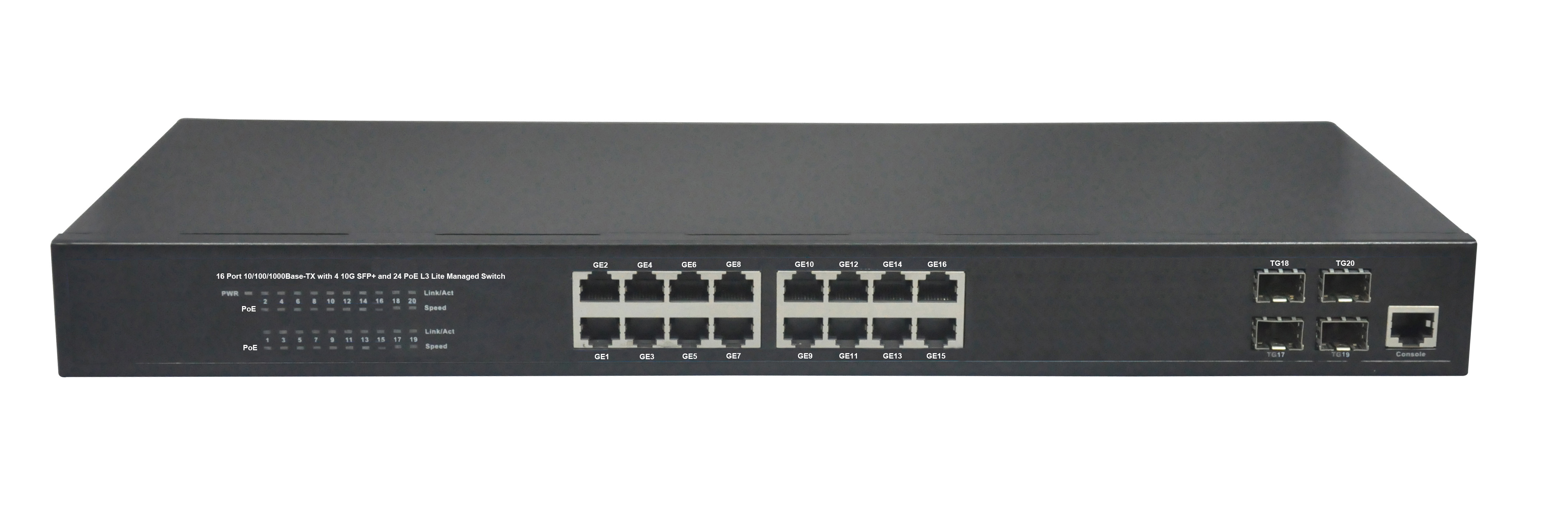
Product Description:
The QN9020-16P+4F(U)-270W is a 10G L3 Lite POE switch. It provides 16 10/100/1000Mbps Auto-Negotiation RJ45 ports, 4 10G SFP+ Ports and 16 POE ports
The QN9020-16P+4F(U)-270W is a new generation Ethernet intelligent access switch. It is mainly deployed on the IP MAN and intranets, meeting requirements the requirements of carrying various Ethernet services and accessing the Ethernet. It also provide the PoE function for powering of wireless LAN (WAN) access points, IP security cameras, VoIP telephone and other low port density installations.
The QN9020-16P+4F(U)-270W is a 19’’ case-shaped device with 1U high. It is with the internal industrial power supplies, have three optional power supplies—270W, 400W. All POE ports support both IEEE802.3af and IEEE802.3at Standard; each port can output 30W max.

Product Features:
• Conforms to IEEE802.3, IEEE 802.3u, IEEE 802.3ab, IEEE802.3z, IEEE802.3af IEEE802.3at
• Provides 16 10/100/1000 Base-TX ports and 4 10G SFP+
• Provides 16 PoE injector and build in AC power
• High back-plane bandwidth 112Gbps
• Support standard IP/ Extend IP / MAC IP / ARP ACL
• IGMP snooping and IGMP Query mode for Multi-media application
• Port mirror and bandwidth control
• Supports GVRP function
• IEEE802.3x Flow control
• Support Port Based VLAN / 802 .1Q Tag VLAN
• Support IEEE802.3ad Port trunk with LACP
• Support Spanning tree protocol IEEE 802.1d
• Supports IEEE 802.1p class of service
• Support IEEE 802.1x user authentication
• Support Broadcast storm filter
• Support DHCP server and client
• Support System event log
• Support command line interface management
• Management by Web/SNMP/Telnet/Console
• Surge protection for power port and data ports
• EMI standards complies with FCC, CE class B

Product Specifications:
Item | Description
Summarize
Fixed port | 16 10/100/1000Base-TX ports.  4 10G SFP+.  1 Console port.
LED Indicators | PWR, PoE, 1000M and Link/Act LED.
Input voltage | 100V～240V AC，50/60Hz
Power consumption | 270W/400W
Operating temperature | 0℃～40℃.
Storage temperature | -10℃～70℃.
Relative humidity | 20%～85% (non-condensing).
Thermal methods | Built-in Noiseless FAN.
PoE
PoE port | 8/16 10/100/1000Base-TX ports.
PoE Standard | IEEE802.3af & IEEE802.3at, per port 30W (max).
Pin assignment | V- (RJ45 Pin 1, 2), V+ (RJ45 Pin 3, 6).
PoE management | Support Port-base PoE status view and control.
Layer 2 Switching
Switching capacity | 112G
MAC address table | 16K, Support MAC address table management.
MAC Address Binding | Support.
MAC Address Filtering | Support.
MAC Address Learning control | Control number of port-based MAC address learning.
Jumbo Frame | Jumbo packets up to 16 Kbytes.
Port Feature | Port Control.  Port Isolation.  Port Self-loop Detection.
Port Mirroring | Support.
VLAN | 4K 802.1q VLANs, Support Ingress filter.
Link Aggregation | Up to 32 maximum aggregation groups, each containing up to 8 GE ports.
Traffic control | IEEE 802.3x full-duplex flow control.
Rate Limit | Unit: 64kbps.
Spanning Tree | IEEE 802.1d Spanning Tree Protocol (STP)  IEEE 802.1w Rapid Spanning Tree Protocol (RSTP)  IEEE 802.1s Multiple Spanning Tree Protocol (MSTP)
Ring Protocol | Support EAPS.
Multicast | Support 256 Multicast groups.  Support IGMP Snooping.
Layer 3 Switching
Static ARP | Support.
Static Routing | Support.
L3 VLAN interface | Up to 32 L3 VLAN Interface.
Convergence
QoS | 4 output queues on each port.  Support flexible queue scheduling algorithms: WRR, Q+WRR.  Support port-based / MAC-based / 802.1p / DSCP classification.
Security
ACL | Support Standard IP / Extend IP / MAC IP / ARP  Support 1024 entries
Security Features | Support MAC-based 802.1X authentication.  Support AAA/RADIUS authentication.  Support WEB/Telnet password protection.  Support Accessing privilege mode password protection.
Self-protection | Support CPU Self-protection.
Management
CLI | Support CLI (Commend Line Interface) configuration mode.
Console | Support Configuration via the console port.
Telnet | Support Local/remote configuration via Telnet.
WEB | Support WEB management system.
SNMP | Support System configuration with SNMP v1/v2/v3.
User Management | Support Multi-user management.
System Log | Support.
Configuration File Download/Upload | Support Download/Upload configuration File via WEB/TFTP.
Upgrade Firmware | Support Upgrade Firmware via WEB/TFTP/Console.
Debug
PING | Support.
TRACEROUTE | Support.
Telnet client | Support.
Process View | Support.

Order Information
QN7018-16P+2F-270W | 18 ports network Switch with 16 PoE Ports(Total Power 270W)
QN7018-16P+2F-400W | 18 ports network Switch with 16 PoE Ports(Total Power 400W)

